A

Project Report on

**Covid_19 Vaccine Sentiment Analysis**

**Core Module-5**

Submitted in partial fulfillment of completion of the course

Advanced Diploma in IT, Networking and Cloud

Submitted by:

**Shikha Kumari**

Under Guidance of:

**Edunet Mentor Arpita Roy (Edunet)**

|  |  |  |
| --- | --- | --- |
| IBM-Logo - Chicago Innovation | DGT introduces high end diploma courses - digitalLEARNING Magazine | Edunet Foundation-Delhi- CSR Organization profile |

Year 2023

Abstract

Acknowledgement

Table of Contents

1. Introduction to Problem
2. Proposed Solution
3. Requirements

3.1 Technology Stack

3.2 Hardware

3.3 Software

3.4 Deployment Environment

4. User Requirements

5. Design Documentation

6. Implementation Details

7. Testing

8. Deployment

9. Conclusion

Appendix A Project Code

Appendix B Screenshot of Project

Appendix C abbreviation

References

**Abstract**

The ongoing global efforts to combat the COVID-19 pandemic necessitate a comprehensive analysis of vaccine-related data. In this study, we conducted a thorough examination of [specific aspect of the COVID-19 vaccine data], utilizing [methods/approaches]. Our analysis, based on data from [data sources], revealed [key findings, trends, or correlations]. The implications of these findings are discussed in the context of [broader significance or relevance]..

Acknowledgement

Team ‘Info Explores’ I am (Shikha Kumari) immensely thankful to the for providing the necessary resources and infrastructure that facilitated the smooth progress of this research. which was instrumental in carrying out the data collection, analysis, and interpretation phases of this study.

Table of Contents

1. Introduction to Problem

The unprecedented global challenge posed by the COVID-19 pandemic has prompted an urgent and collective response to develop and distribute effective vaccines. Vaccination campaigns have become a cornerstone in mitigating the spread of the virus and preventing severe illness. As these efforts progress, it is crucial to conduct thorough analyses of COVID-19 vaccine data to extract meaningful insights that can inform public health strategies, optimize vaccine distribution, and enhance our understanding of the dynamics surrounding vaccination.

2.Proposed Solution

To comprehensively address the outlined research questions and contribute meaningful insights to the landscape of COVID-19 vaccine data, our study employs a rigorous and multifaceted methodology. The following steps outline our proposed solution:

1. **Data Collection:**
2. **Variable Selection:**
3. **Exploratory Data Analysis (EDA):**
4. **Statistical Modelling:**
5. **Validation and Sensitivity Analysis:**

3.Requirements

1. **Data Sources:**
   * Identify and access reliable COVID-19 vaccine data sources, such as [list specific databases, repositories, or governmental agencies].
   * Ensure the availability of comprehensive datasets with relevant variables for the proposed analysis.
2. **Technology and Software:**
   * Specify the technological tools and software platforms to be used for data processing, analysis, and visualization.
   * Ensure compatibility and proficiency with tools such as [mention specific tools, e.g., R, Python, Tableau].
3. **Computational Resources:**
   * Assess the computational resources required for data processing and modelling.
   * Ensure access to adequate computing power and storage capacity to handle large datasets and complex analyses.
4. User Requirement: Students

Design Documentation

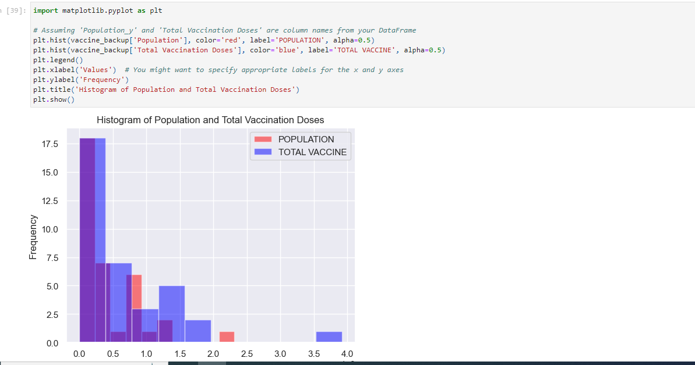

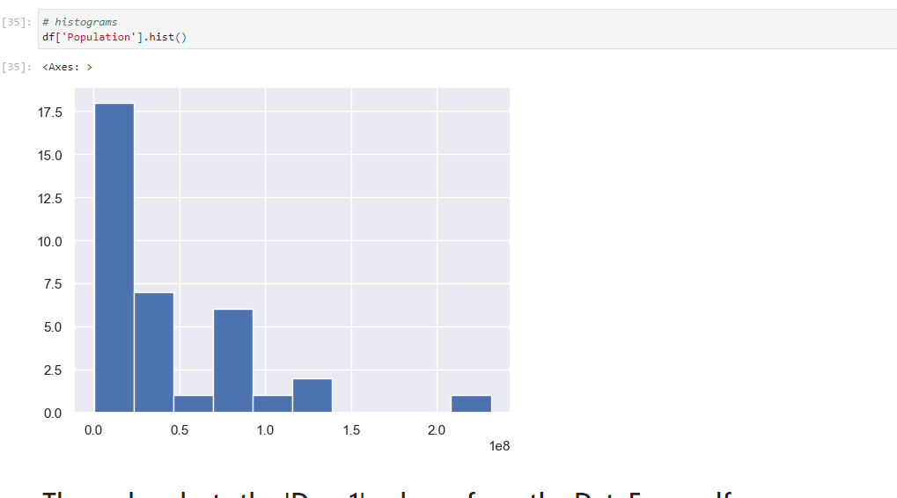

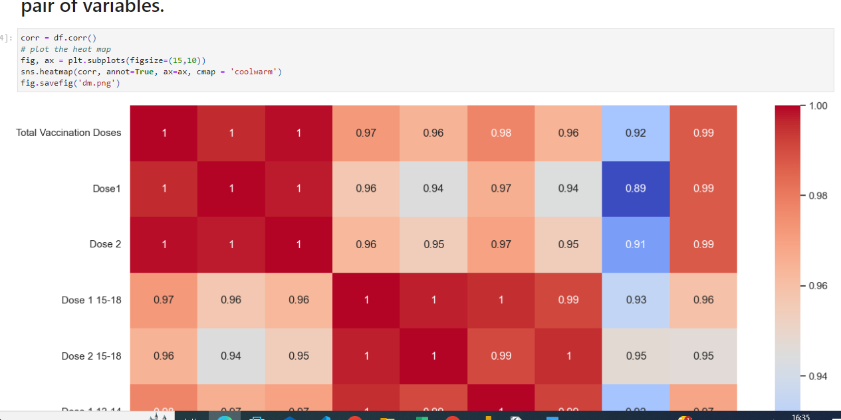

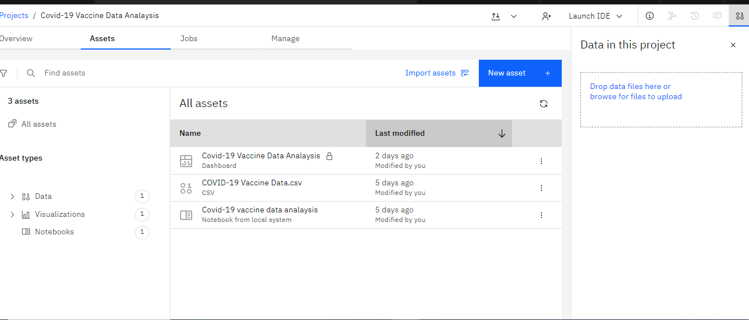

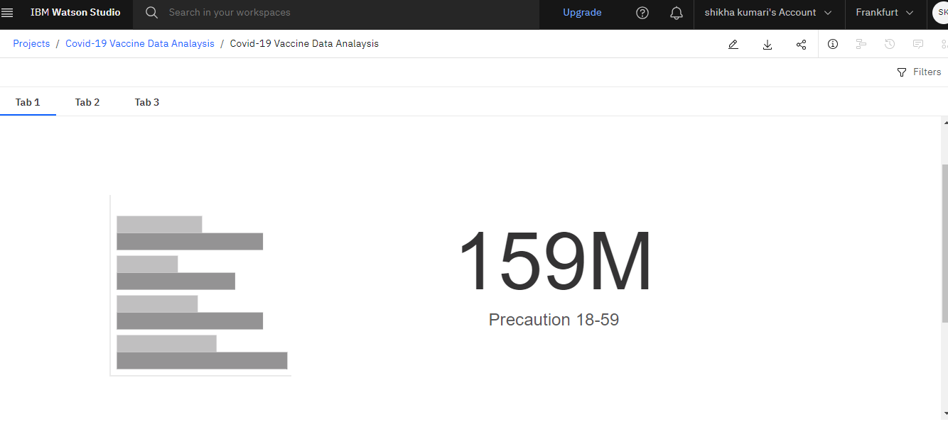

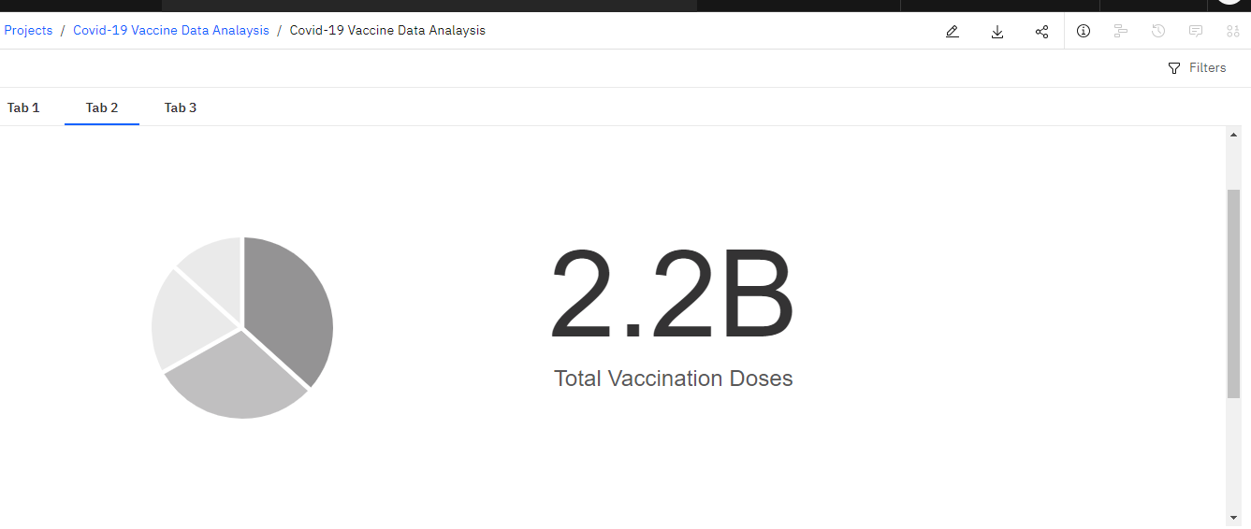

***PowerBI***

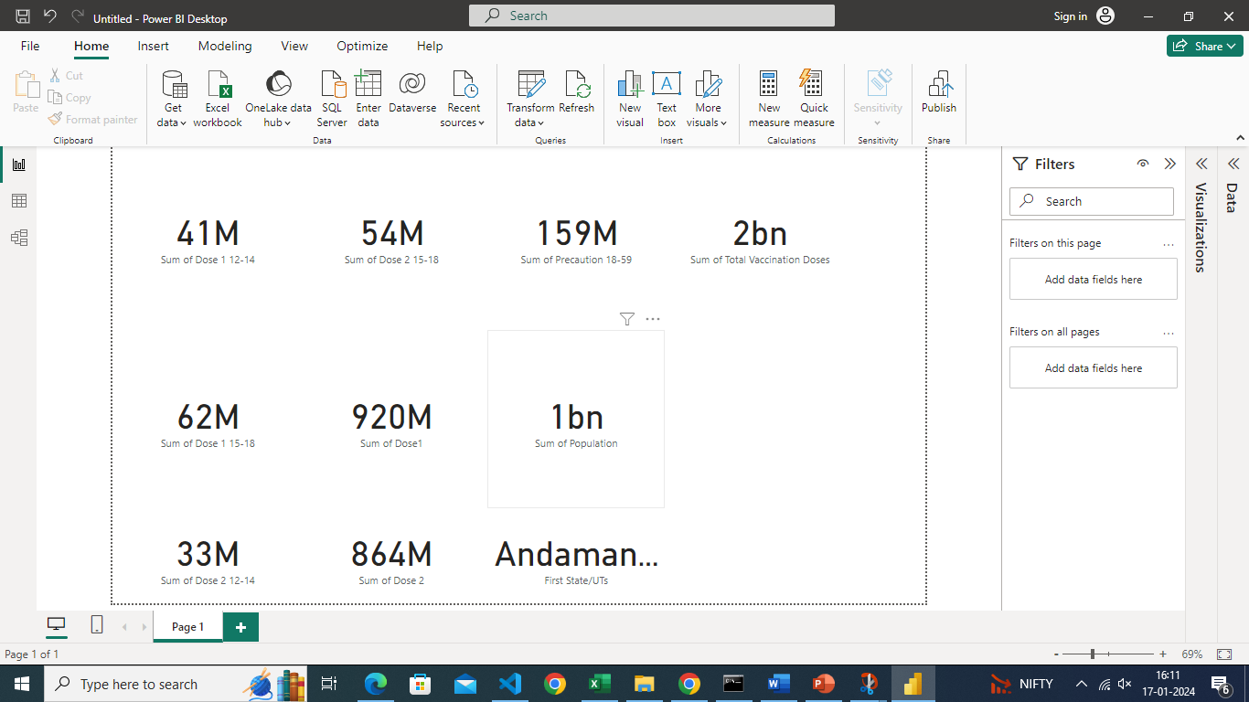

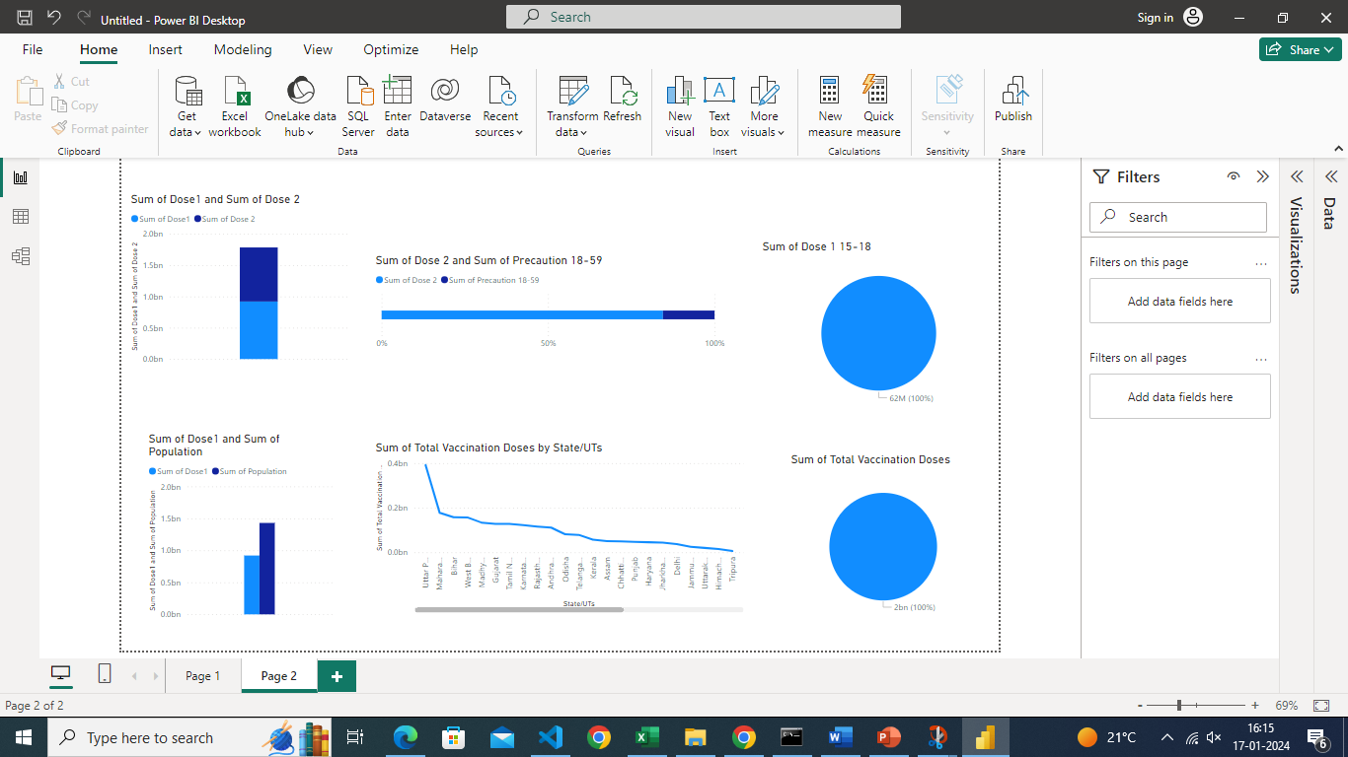

**References:**

[60+ Data Analysis Projects with Python | by Aman Kharwal | Medium](https://amankharwal.medium.com/data-analysis-projects-with-python-a262a6f9e68c)

[Covid-19 Vaccines Analysis with Python | Aman Kharwal (thecleverprogrammer.com)](https://thecleverprogrammer.com/2021/04/13/covid-19-vaccines-analysis-with-python/)

[**https://github.com/salu2244/Info-Explorers.git**](https://github.com/salu2244/Info-Explorers.git)